Trade Mission Pricing:
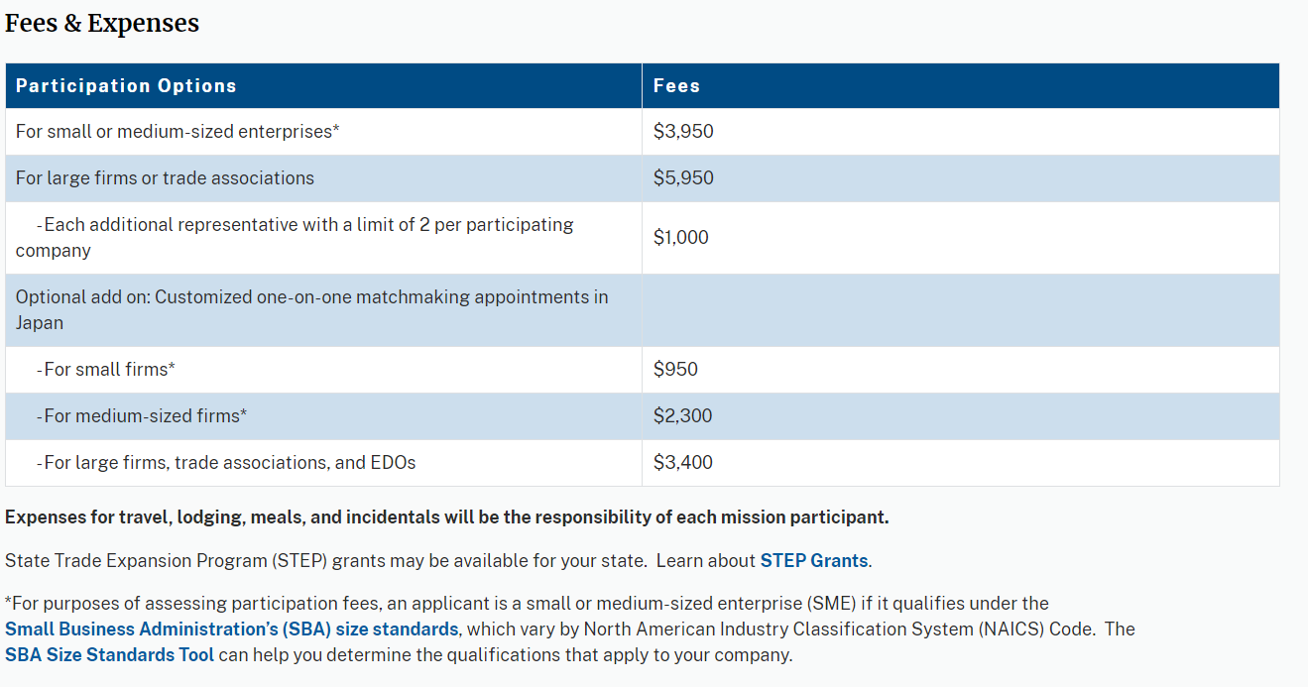
Note: pricing for EDOs is the same as for “small” companies: Mission fee-$3,950, additional representative-$1,000, Japan-$950. The website + above chart will be corrected shortly.

Step Grants:
Verify STEP Grant availability for your state at this link: https://www.sba.gov/funding-programs/grants/state-trade-expansion-program-step/directory-step-awardees

SBA Company Size Standards:
Verify company size using the SBA Size Standards Tool: https://www.sba.gov/size-standards
ITAP Show Booth Space Pricing:
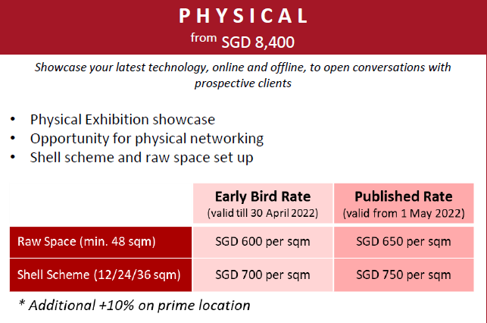
Early bird booth price is valid until April 30, 2022. Booth space can be confirmed until September unless sold out. For overseas exhibitors, best to confirm by mid-July, 3-months in advance of the show. Look up current exchange rate here: https://www.xe.com/

Hotel Prices – Singapore
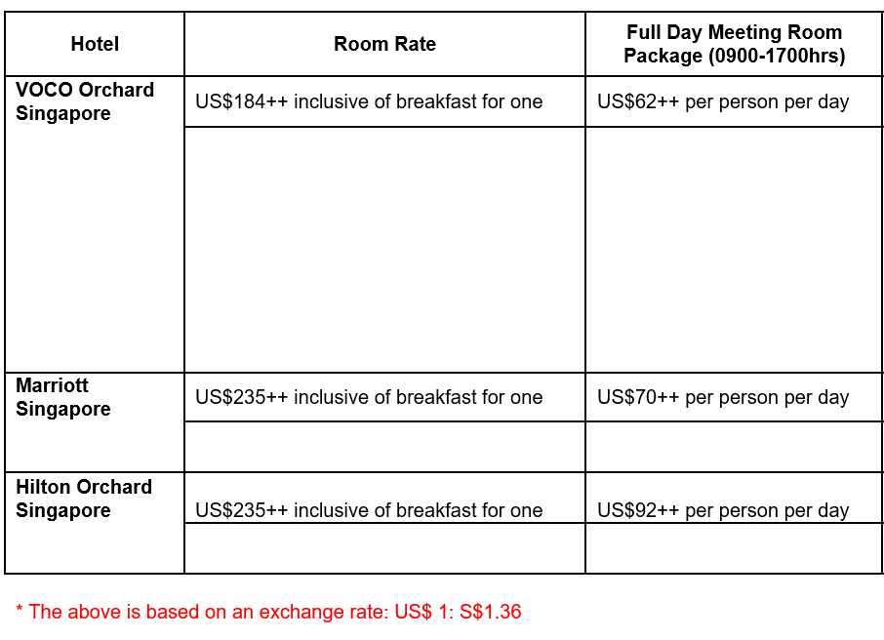
Hotel Prices – Japan:
$240 US per night/29,500 JPY per night
Price in US dollars is based on April 12, 2022, exchange rate; this may fluctuate.
Hotel Prices – Indonesia: [TBD]

